

Dr. Jennifer, Lopez inc.

2015-04-08

Dr. Lopez

PSC 0717, Box 8261, APO AE 15928

Phone: 6196424210

Fax: 9836460431

**Re:** Kelly, Yoder

**PHN:** 9431900758

**Birthdate:** 16-Sep-1986

**Address:** 15674 Jeremiah Estate, Ericborough, DC 40997

**Patient number:** 4603515610

To Whom It May Concern:

This is a medical letter to state the above patient is pregnant with expected delivery date of 04-Feb-2025. Hoping this information is satisfactory for your requirements.

Thank you.

Sincerely,

Dr. Jennifer, Lopez

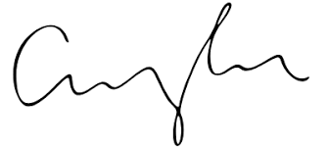

FRCS© NCMP

Clinical Assistant Professor, UBC

Department of Obstetrics and Gynecology SMH